For Immediate Release Contact: Name
May X, 201X Phone Number
Email Address

MAKES IT PURPLE TO SUPPORT FALLEN FIRST RESPONDERS
Communities Encouraged To Participate

(Insert City/State/date) – Hundreds of first responders: police, fire and EMS have died in the line of duty, from cancer, from COVID, and due to suicide, in Texas since 2000. It’s a scary number and it’s one of the reasons why the Texas Line of Duty Death Task Force has launched the Make It Purple: Fallen First Responder Awareness Month and the Dress in Purple Day. This event will help incite awareness of what our local first responders go through on a day to day basis, as well as for those that have died in the line of duty and their families that they have left behind.

“We want to make a difference in the lives of our local first responders, their families, and their communities. Our Make It Purple: Dress in Purple Day event encourages citizens to go out and encourage local first responders, talk to loved ones about how they can support them, and to remember those that lost their lives in the line of duty. By creating more awareness around this issue, we will help provide more support and care to those that continue to serve and to those families that have been left behind,” said Wendy Norris, President of the Texas LODD Task Force. “It’s important that we do our part by helping these families.”
Along with the Texas LODD Task Force, Governor Greg Abbott has proclaimed May to be Fallen First Responder Awareness Month. He states, 'Texans owe a debt of gratitude to all of our first responders who dedicate themselves to serving the public and put their lives on the line every day to ensure our safety. These men and women are examples of courage and honor, and it is our duty to honor their sacrifice and remember the legacy they leave behind.’
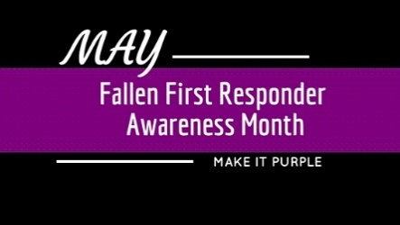
Dress in Purple Day is held on the second Thursday in May in communities, emergency services agencies, businesses, and offices throughout the State of Texas. The Texas LODD Task Force launched the Make It Purple program in 2016 to bring statewide attention to the fact that many of our first responders have lost their lives in the line of duty and that they leave families and loved ones behind. They also want to celebrate the courage of those first responders that are serving their communities day in and day out.
We would like to encourage your group to participate by wearing purple (and black) and urging others to do the same. Purple and black is recognized colors on bunting used during memorials and funerals for the fallen. By “Making It Purple” we hope to raise public awareness and support the families of the fallen and our first responders.
For more information and to get involved, visit www.makeitpurple.org.
# # #

